UNIT/04: FOOD AND DRINK
READING
IN THIS unIT YOU WILL
LEARN HOW TO
- locate and match information from a text
- complete gapped sentences
- correct common errors in the use of countable/uncountable nouns
- use some, any, much and many.

Lead-in

 | Find the foods in the pictures and then put the food words into the correct column: countable or uncountable.  Examples: Apple is a countable noun - we can say three apples.  Bread is an uncountable noun - we can't say three breads.
  01
  burger | cereal | chips | curry | fish | mashed potato
  chicken | noodle | rice | salad | toast | vegetable
  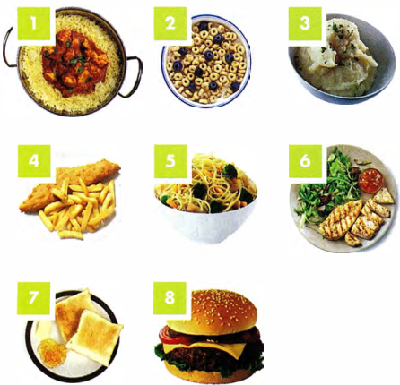
  Countable | Uncountable
 | Answer the questions.  Which of the foods above do you eat regularly?  Which do you like/dislike?  What foods are typical of your country?
  02

LOCATING INFORMATION IN A TEXT

 | Read the text in one minute. Then cover it and tell your partner what you can remember.
  03

FOOD
CULTURE SHOCK
A CHARLES  You would think that eating with your fingers would be easy. In the US, there are only certain things you can eat with your fingers, like burgers, for example, and that's easy enough. When I went to South India, though, I realised that it is a whole new skill to learn to eat rice and curry with your fingers. You have to mix the curries together and with the rice and form a 'ball'. Daal is particularly helpful as a kind of glue.  You use your fingertips, never the palm of your hand, and use your thumb to pop it into your mouth. I thought I knew where my mouth was, but my first few attempts were a disaster. There was food everywhere!  *Daal is a lentil curry widely eaten in the Indian subcontinent.  C QIANG SHI  I enjoy trying food from different countries, but what interests me more is the culture and habits surrounding food and eating. In China, when we go to a restaurant with colleagues, when we are offered something, we say 'No thanks', even though we want it, because the person will definitely repeat the offer. In other countries, though, 'no' means 'no', so if you are just trying to be polite and don't take it the first time, you will end up with nothing! To me, it feels wrong to take something the first time it is offered, so it took me a while to get used to that when I travel abroad. | B ALFREDO  For me, when I travel, the 'fast food' culture always shocks me. I can't believe there are people in the world who live on 'junk food' like burgers and just grab a sandwich for lunch. Back home, food is very important to us. We cook fresh food for lunch and dinner and sit down and eat as a family at least once a day, twice at weekends. A lot of people grow their own vegetables and keep chickens. Food is part of your identity, so what are you saying about yourself when you eat some rubbish which contains chemicals and goodness knows what else? The worst thing I have seen on my travels is a baby being given a fizzy drink in a bottle. That really shocked me!  D PAULINE  Being a vegetarian is so easy here in the UK that we forget that not everyone in the world understands vegetarianism. For vegans the situation is even more difficult. Probably the best place I've been to is India, as everything is divided into 'veg' or 'non veg' so you know exactly what you're getting. In many countries, they don't even realise that there is a concept of not eating meat for ethical reasons. In many parts of the world, meat equates to prosperity, so the idea of going out for a meal and not having meat is alien to them. I have travelled to places where, as a vegetarian, all I have been able to eat is salad, fruit and chips. I'm glad to get home where we have special vegetarian products.
E AILEEN
I think breakfast is the meal where food culture shock really hits you. In Australia, there are certain foods you eat for breakfast and certain foods you don't. We usually eat cereal or toast, maybe yoghurt and fruit. We would never eat chicken or vegetables. But when I travelled in Asia, I realised that in many places, there is no difference between breakfast and dinner: rice, curry, noodles, soup, steamed vegetables and fish all appeared at breakfast. Even though I love all those things, I just can't face them at breakfast!

 | Quickly find the following information in the text.  - a food that can be used as a 'glue'  a meat not usually eaten for breakfast In Australia  a country where 'no' doesn't always mean 'no'  an example of a 'junk food'  a country which is easy for vegetarians  a food eaten with fingers in the US
  04
  ◉
  Paraphrase
  To answer some questions, you need to recognise paraphrase.
  Question: Who is concerned about healthy eating?
  Answer: Alfredo.
  Paragraph B doesn't use the phrase 'healthy eating' but these clues help us find the answer:
  …the 'fast food' culture always shocks me.
  …what are you saying about yourself when you eat some rubbish which contains chemicals...?
  The worst thing I have seen... is a baby being given a fizzy drink.
  ◉
  Some questions require you to find very specific information quickly. This exercise will help you practise this skill.
 | Match questions 1-6 with the evidence a-f.  Who:  - realised that some people eat the same dishes for different meals?  - dislikes the takeaway culture?  - discusses travelling for people on a special diet?  - talks about what is considered polite in different cultures?  - found it difficult to learn a new way of eating?  - talks about producing your own food?  - ... we forget that not everyone in the world understands vegetarianism.  - I thought I knew where my mouth was, but my first few  - attempts were a disaster. There was food everywhere! A lot of people grow their own vegetables and keep chickens.  - I can't believe there are people in the world who live on 'junk food'  - In China, when we are offered something, we say  - 'No thanks'... In other countries, though, 'no' means no'  - But when I travelled in Asia, I realised that in many places, there is no difference between breakfast and dinner
  05

[[[[[[[[[[SENTENCE COMPLETION]

 | Complete these sentences using a word from the text.  - In China, if you refuse food, the host will usually ___ the offer.  - For Alfredo, food plays an important role in a person's ___.  - In India, you should not use your ___ when eating.  - In some countries, eating meat represents ___.  - In many places in ___, there is no difference between foods eaten for breakfast and dinner.
  06
  ◉ Being able to locate information quickly will help you in questions where you need to find a suitable word to complete a sentence.

GRAMMAR FOCUS: COUNTABLE AND UNCOUNTABLE NOUNS

 | Correct the errors in these sentences.  - Fresh fruit are healthy and we should eat them every day.  - Chips cooked in the oven is healthier than fried chips.  - The burgers and the pizza are the cheapest foods you can buy.  - In the India it is easy to find the vegetarian food.  - My favourite food is chickens.
  07
 | Complete the sentences with some, any, much or many.  - There are ___ mushrooms in the fridge.  - Are ___ people vegetarian in your country?  - I don't put ___ sugar in my tea - just half a spoonful.  - Do we have ___ flour left?  - Can I have ___ more cake, please?  - How ___ rice do you eat every week?
  08

[[[[[[[[[[EXAM SKILLS]
FOOD TV: education or entertainment?
A
Shows about cookery have become more and more popular all over the world. But what are the reasons for this, and does it make us cook more? In the UK, BBC viewers complained to the programme Points of View that there were too many cookery shows on TV. In one week, the BBC showed 21 hours of cookery. When shows on other channels were included, this came to an amazing 434.5 hours of food TV.
B
In the past, TV cookery shows were there to teach people how to cook. One of the first famous TV cooks, Julia Child, was American. She began her career as a cook when, in 1948, she moved to Paris and learnt to cook sophisticated French cuisine because her husband loved good food. On her return home, she published a collection of French recipes made simple, for ordinary American housewives to use, which was an instant success. She was invited to do a TV show, where her humour and strong personality soon won her great fame.
C
Nowadays TV chefs are famous for all sorts of different reasons. Gordon Ramsay, for example, is an interesting TV chef. He is famous for having a bad temper and using foul language. In his TV show, Hell's Kitchen, he shouts at his staff when they make mistakes because he wants all the food at his restaurants to be perfect. He has many restaurants in different ccuntries. Jamie Oliver is a good-looking, working-class boy who made healthy eating fashionable. He believes children should eat healthy food and he worked with the government to make school meals healthier. His style of cooking is quick, easy and fun.
D
There are some famous pairs of TV cooks as well. The Hairy Bikers are a pair of chefs who have beards and ride motorbikes. They travel around to different places and cook there. They were both fat but then did a series of shows on how to cook diet food and both lost weight. Another famous pair was the Two Fat Ladies. They cooked unhealthy food using lots of fat and they didn't care about healthy eating. They also rode a motorbike.
E
The introduction of a competitive element to many cookery shows reminds us that food TV is more entertainment than education these days. Many of us love shows like Masterchef, where a contestant is eliminated on every show. The personalities of both the contestants and the judges are far more important than the cookery. In a popular competitive show called The Great British Bake-Off, there was a 'nice judge', Mary Berry, and a 'nasty judge', Paul Hollywood.
F
We know that cooking at home is better for us than eating ready-made or takeaway meals. However, the fact that there is more cookery on TV doesn't necessarily mean people cook more. Different studies have produced different results, but most agree that people generally spend less time cooking than they did in the past. Certain cookery shows influence viewers more than others. One study found that the most influential show was Jamie Oliver's 15 Minute Meals, which influenced 21% of viewers. This may be because his method is to cook quick, simple, healthy meals rather than 'restaurant-style' food.
G
It seems, though, that teaching children to cook at home and at school has much more influence on healthy eating than watching TV programmes on cooking. Grandparents have an important role to play because they may have more time -and experience - than parents. Cooking with family members on a regular basis and making food preparation part of the school curriculum is likely to ensure that children become adults who can and do cook.

 | Read the article about Food TV. Which paragraphs contain the following information?  Write the correct letter, A-F.  [NB You may use any letter more than once.]  - The cooking show that affects people most  - A TV chef who was first famous as an author  - The number of food shows on TV  - The role of cookery shows for enjoyment rather than learning  - Why children should be taught to cook at school  - Research about the amount of time people cook  - Examples of famous cookery partners
  09
 | Look at the following descriptions (1-7) and the list of famous chefs. Match each description with the correct chef, A-F.  [NB You may use any letter more than once.]
  10
  - The cooking show that affects people most  - A TV chef who was first famous as an author  - The number of food shows on TV  - The role of cookery shows for enjoyment rather than learning  - Why children should be taught to cook at school  - Research about the amount of time people cook  - Examples of famous cookery partners | - Mary Berry  - Jamie Oliver  - The Hairy Bikers  - Gordon Ramsay  - Julia Child  - Two Fat Ladies

UNIT/04: FOOD AND DRINK
WRITING
IN THIS unIT YOU WILL
LEARN HOW TO
- deal with a Part 1 question with two diagrams
- describe data without exact numbers
- compare data in a pie chart
- decide what information to include.

Lead-in

 | Read the task and look at the diagrams below.  The charts below show the favourite takeaways of people in the UK and the number of Indian restaurants in the UK between 1960 and 2015.  Summarise the information in both charts by selecting and reporting the main features, and make comparisons where relevant.  Write at least 150 words.
  01
  Diagram 1  Favourite takeaways in the UK  (A takeaway is a meal you buy in a restaurant or shop to eat at home.)  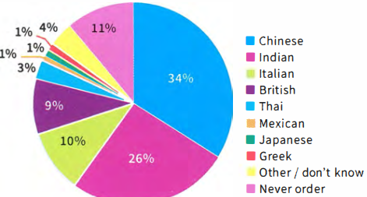 | Diagram 2  Number of Indian restaurants in the UK  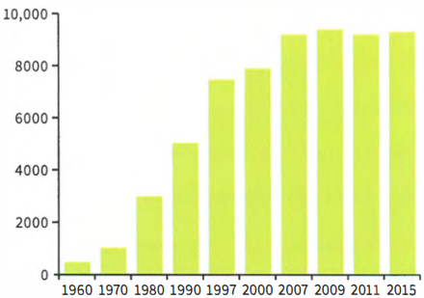
 | Look at the following expressions. Which are more suitable for diagram 1 and which are more suitable for diagram 2?  - the highest proportion of people  - only a very small number of people  - there has been a steady increase  - a very small drop  - about a third of people  - approximately a quarter of people  - the greatest rise took place
  02

[[[[[[[[[[DESCRIBING TWO DIAGRAMS]
INTRODUCTION AND OVERVIEW

 | Complete this introductory sentence and overview. Write one word in each gap.  The 1 ___ chart shows which type of takeaway food is the most popular in the UK, while the 2 ___ chart shows how many Indian· restaurants existed in the UK between 3 ___ and 4 ___. We can see that 5 ___and Indian takeaways are the favourites, and that the number of Indian restaurants in the UK 6 ___ steadily during this period. | TIP 03
  03
  ◉ Sometimes you will have to write about two separate types of diagram in the same task.
  When you are working with two diagrams, your first sentence should introduce both of them and your overview should summarise both of them.

DESCRIBING NUMBERS IN A PIE CHART

 | Match the percentages from the pie chart with their descriptions.
  04
  - 34%  - 26%  - 10%  - 1% | - a tiny proportion  - about a quarter  - just over a third  - one in ten

MAKING COMPARISONS

 | Look at diagram 1 and complete the sentences about the pie chart with the words in the box. One word is used twice.  - The ___ popular type of takeaway is Chinese.  - The three ___ popular types are Mexican, Greek and Japanese.  - Italian takeaways are slightly ___ popular than British takeaways.  - Japanese food is ___ popular than Thai food.  - ___ people like Chinese food than Indian food.  - ___ people like Mexican food than Thai food.
  05
  fewer | least | less | more | most

GRAMMAR FOCUS: COUNTABLE AND UNCOUNTABLE NOUNS

 | Choose the correct words to make true sentences.  More and less are used with countable / uncountable nouns.  More and fewer are used with countable / uncountable nouns.
  06

 | Put the nouns into the correct column.
  07
  restaurant | coffee | farm | country | home | land
  language | meat | oil | person | home animal | sand
  Countable | Uncountable
 | Complete the sentences with more, less or fewer. Use the information in the chart.  - China has ___ land than India.  - India has ___ land than China.  - In India, ___ people live in cities than in China.  - India has ___ official languages than China.
  08
  Countable | China | India
  land | 9,596,960 square km | 3,287,263 square km
  percentage of population living in cities | 50.5% | 31.3%
  official languages | Mandarin Chinese | 22 official languages

GRAMMAR FOCUS: ARTICLES

 | Correct the errors with articles in these sentences about diagrams 1 and 2.  - Number of Indian restaurants in UK has risen.  - The Chinese food is the most popular.  - Second most popular food is Indian.  - There was small drop in the number of Indian restaurants in 2011.  - There were about thousand Indian restaurants in 1970.
  09

DESCRIBING DIAGRAMS WITHOUT EXACT NUMBERS

 | Some graphs or charts do not give the exact numbers. It is important to show that the number you use is not exact. Match these numbers with their description.
  10
  - 8950  - 2019  - 500,070  - 3946  - 103  - 7223 | - approximately 4000  - about a hundred  - just under 9000  - between 7000 and 7500  - around half a million  - a little over 2000

 | Look at these examples from a description of diagram 2.  There were about 500 Indian restaurants in the UK in 1960.  The number rose from approximately 5000 in 1990 to just under 8000 in 2000.  The figure for 1997 was around 7500.  From 2007 to 2015 the number of restaurants was between 9000 and 9500. In 1970 there were a little over 1000 Indian restaurants.  Use the expressions in bold to complete the sentences about diagram 3, which shows the market share of four supermarkets.
  11
  - In 1995, Foodhall had ___ 20% of the market, while Finco had ___ 20%.  - In 1995, Bestway's share of the market was ___ 5%.  - In 2005, all the supermarkets had ___ 11% and 30% of the market.  - In both 2005 and 2015, Alton's share of the market was ___ 16%.  - Finco had the biggest market share in 2005, which was ___ 30%. | 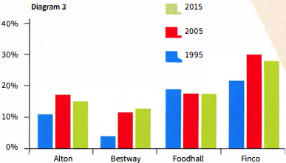

STUDYING A MODEL ANSWER: AVOIDING 'OUTSIDE' INFORMATION

 | Read the model answer, which is based on diagrams 1 and 2. Two sentences should not be included. Can you find them?
  12
 | Read the model answer again and find:  - the overview  - a sentence that explains the link between the two charts  - a comparison  - a passive form  - a way of saying '1990 to 2000'  - an expression meaning 'has not changed much'  - an expression used to avoid exact numbers  TIP 13 | MODEL ANSWER
  13
  Never include any information that is not shown in the diagram. Even if you know a lot about the data given, do not try to explain the reasons for it or give your own opinion.
  The pie chart shows which type of takeaway food is the most popular in the UK, while the bar chart shows how many Indian restaurants existed in the UK between 1960 and 2015. We can see that Chinese and Indian takeaways are the favourites, and that the number of Indian restaurants in the UK rose steadily during this period.
  The pie chart shows that Chinese and Indian takeaways are much more popular than all the others, at 34% and 26%, There are another two types that quite a lot of people like. These are Italian at 10% and British at 9%. It is not surprising that people in the UK like British food as fish and chips is the national dish, Greek, Japanese and Mexican were only chosen by 1% of people.
  The pie chart shows us that Indian food is popular and the bar chart shows how its popularity grew. Even my village has an Indian restaurant! There was a rising trend from 1960 onwards. The increase was greatest in the 1990s, from about 5000 restaurants in 1990 to almost 8000 in 2000. Since 2007, the number has remained stable at just over 9000.

[[[[[[[[[EXAM SKILLS]
 | Read the exam question below and study the charts, then answer these questions about the data.
  14
  - What is the main trend revealed in the bar chart?  - Which ten-year period showed the first significant increase?  - What happened in the ten-year period after that?  - What is the link between the two charts?  - In 2015, what percentage of people were severely obese?  - Which was the largest group in 2015? | You should spend about 20 minutes on this task.  The bar chart shows the percentage of adults who were overweight or obese (too fat or much too fat) in one country from 1965 to 2015. The pie chart shows the proportion of adults who were overweight, obese or severely obese in 2015.  Summarise the information by selecting and reporting the main features, and make comparisons where relevant.  Write at least 150 words.
  Percentage of adults who are overweight or obese  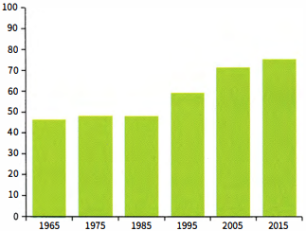 | Weight range of the adult population 2015  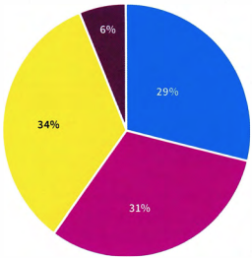
    ☐ Healthy or underweight | ☐ Obese (too fat)
    ☐ Overweight | ☐ Severely obese (dangerously fat)
 | Now write your report. Remember:  - Include an overview.  - Don't try to include all the data.  - Don't include anything from outside the data.
  15

UNIT/04: FOOD AND DRINK
LISTENING
IN THIS unIT YOU WILL
LEARN HOW TO
- find synonyms and paraphrase in matching tasks
- identify 'distractors' in matching tasks
- answer classification tasks.

Lead-in
 | Pictures A-G show different areas of work or study. Match the pictures with the words in the box.
  01
  bake | boil | fry | grill
  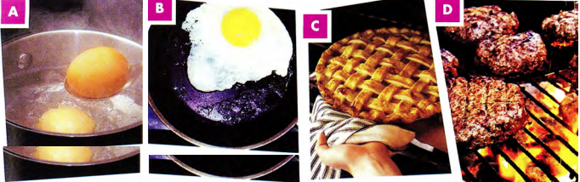
 | Match the words with the type of food they are. Put them in the correct column.
  02
  apples | bananas | beef | biscuits | burger | cake | steak | potatoes
  carrots | chocolate | lamb | cucumbers | pastries | pears | peas | strawberries
  Meat dishes | Vegetables | Fruits | Sweets

[[[[[[[[[[MATCHING TASKS]
 | Listen to two friends talking about a party they are planning. Match Mike's suggestions with Jane's answers.  32  What are they going to prepare?
  03
  Suggestions  - What do you think about preparing a Mexican meal?  - We could have pizza. Everybody likes pizza.  - I know! We could have salad and roast chicken. | Answers  - I think we should have something healthier.  - That sounds like a good idea. Let's do that.  - I think it might be too spicy for some people.
  ◉ In matching tasks in the Listening test, you may hear information about several of the options, but only one of the answers is correct.

 | Listen to two friends talking about preparing a meal. How are they going to prepare the potatoes?  33  Why are the other answers incorrect?
  04
  - boil | - bake | - fry
  ◉ In matching tasks in the IELTS test:
  - you do not need to use all of the letters. You should put one letter next to each numbered question.
  - the questions follow the same order as the information on the recording which you need for the answers.
 | Listen to two friends discussing food shopping. Match the names of the shops (1-3) with the different types of food, A-D.  34  Which option didn't match any of the shops? |  | TIP 04
  05
  - Arcadia  - Best Buy  - Hampton's | Types of food  - vegetables  - meat  - fruit  - sweets
  Listen carefully to what is said about all the options to make sure you choose the correct one.

 | You will hear a radio programme in which two people are discussing the different restaurants in a town.  Look at the names of restaurants (1-3) and the list of types of restaurant.  Match each restaurant with the correct type, A-G.  35  Which option didn't match any of the shops?
  06
  - Adam's  - The Duke  - The Tower | Types of restaurant  - vegetarian  - steakhouse  - seafood  - Italian  - international  - French  - fast food
 | After you have checked your answers, look at the Listening script on page 182 and check why the other options were not correct.
  07
 | Look at the Listening script again and find words that mean the following:  - crowded  - delicious  - cheap  - smart  - inexpensive
  08

FOLLOWING A CONVERSATION

 | Choose the option, A, B or C which does NOT mean the same as the first sentence.  - The price of food in the restaurant is cheap.  - The price of a meal in the restaurant is reasonable.  - The restaurant is excellent if you want a budget meal.  - The food in the restaurant is overpriced.  - Marco cooked us a really tasty meal.  - The meal Marco prepared was delicious.  - Marco cooked us a really unappetising meal.  - The meal Marco made for us was mouth-watering.  - We were served food that was cooked in the old-fashioned way.  - The meal we had was very contemporary in style.  - The meal we had was very traditional.  - The meal was made from a historic recipe.  - When I went to Thailand, I really enjoyed trying the street food.  - I really liked tasting the food that was sold outdoors in Thailand.  - In Thailand I loved the food we bought from stalls in the streets.  - I enjoyed eating at restaurants when I was in Thailand.  - The chef at the Lodge Hotel is very skilful.  - The chef at the Lodge Hotel is bad at his job.  - The chef at the Lodge Hotel has a lot of expertise.  - The chef at the Lodge Hotel is highly trained.  - The ingredients for the recipe can be changed to ones you have available.  - You can use different ingredients to make this dish if you can't find everything.  - You can be flexible about what ingredients you add to this recipe.  - You should follow the recipe strictly or it won't taste good.  - The chef at the new restaurant is famous across the country.  - The chef at the new restaurant is well known nationally.  - The chef at the new restaurant is recognised across the country.  - The chef at the new restaurant is unknown outside of his town.  - I didn't like the soup; it was too spicy.  - The soup had too much pepper.  - The soup wasn't tasty.  - The soup was a bit too hot for my taste.
  09
 | Underline the words which helped you find the answers to exercise 9.
  10

[[[[[[[[[[CLASSIFICATION TASKS]
◉ Sometimes in the test you will be asked to match several pieces of information with three different options. Like with other matching exercises, you must listen for ideas, since the same word will often not be used on the recording as in the question.
The options with letters (A-C) can be used more than once. The numbered information you must find (1-5) will be in the order that you will hear it.

 | Listen to a famous TV chef talking about different countries and their cuisines. Match the statements with the correct country, A-C.  36  - They use chopsticks made of several different materials.  - You can find a lot of different types of regional cooking here.  - This place is famous for hot, peppery food.  - In this country people use recipes that came from different countries.  - This country is well known for its grilled meat.  - China  - Japan  - Korea
  11
[[[[[[[[[[EXAM SKILLS]

 | You are going to hear an interview with a chef about a TV programme he has made about food in China.  Choose FOUR answers from the types of food in the box and write the correct letter A-F next to questions 1-4.  37
  12
  Which of the foods:  - is often enjoyed by children?  - can be cooked in a short time by  - the dinner guests?  - needs expertise to make?  - can be adapted to your tastes? | Types of food  - Beijing duck  - kebabs  - dumplings  - noodles  - hotpot  - jellyfish

UNIT/04: FOOD AND DRINK
SPEAKING
IN THIS unIT YOU WILL
LEARN HOW TO
- talk about food in your country (Speaking Part 1)
- use the preparation time to collect your ideas for Part 2
- organise your talk (Speaking Part 2).

Lead-in

 | Look at the photographs of different dishes. Which ingredients do you think are used to make each one? Match the pictures with the words in the box. Some ingredients are used more than once.
  01
  beef | cabbage | carrots | cheese | chicken
  egg | tomatoes | yoghurt | ginger | chillies
  lamb | onions | soy sauce | rice | spices
  flour | garlic
  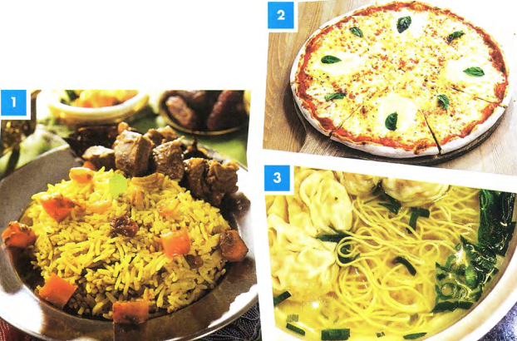
 | With a partner, discuss your favourite food. What ingredients are used to make it?
  02

GRAMMAR FOCUS: COUNTABLE AND UNCOUNTABLE NOUNS

◉Some things we eat are countable and some are uncountable. This changes some of the words we use to talk about them.
Examples:
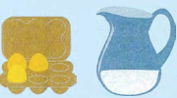  There are some eggs.  There is some water. | 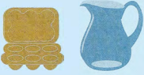  There aren't any eggs.  There isn't any water.
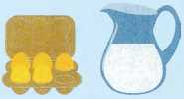  There are a lot of eggs.  There's a lot of water. | 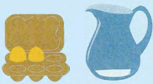  There aren't many eggs.  There isn't much water.

 | With a partner, describe what you can see in the fridge.  Use the sentences below to help you.
  03
  - There ___ eggs.  - There ___ cheese.  - There ___ milk.  - There ___ carrots.  - There ___ bananas.  - There ___ orange juice. | 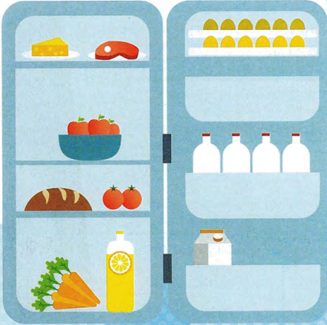

FOLLOWING A CONVERSATION

 | Listen, then read Mohammed's answers to these Part 1 questions about food. Are the phrases in bold positive or negative opinions?  38
  04
  Examiner | What kind of food is popular in your country?
  Mohammed | These days a lot of young people actually enjoy Western food like pizza and fried chicken. Our national food is often too spicy, especially for children and foreigners, and also it takes too long to cook. I think that it's delicious though!
  Examiner | What do you think of Western food?
  Mohammed | Well, I suppose Western food is quick to make and is tasty too, so everyone can eat it without too much trouble. I think that a lot of people like food to be convenient because they're so busy nowadays.  Is there any kind of food you don't like?
  Examiner | Is there any kind of food you don't like?
  Mohammed | Yes, I'm not keen on sushi at all. It's so strange eating something that hasn't been cooked. I know it's very fresh and healthy but I just don't like the taste and I can't stand the texture - it's too chewy for me.
  Positive | Negqative
 | Answer the three questions in exercise 4 with a partner. Use some of the positive and negative phrases in the box.
  05

USING THE PREPARATION TIME IN PART 2

 | Listen, then read Mohammed's answers to these Part 1 questions about food. Are the phrases in bold positive or negative opinions?  39  Look at the task card and listen to Angelica talking about a meal that is popular in her country. Then answer the questions below.  Describe a popular meal from your country that you like to eat.  You should say:  - what the meal is  - why it is popular in your country  - why you like it  and say why you would recommend it to a visitor to your country.  - Did Angelica introduce what she was going to talk about?  - What was the meal that Angelica described?  - Why is it popular in her country?  - Why does she like it?  - Why would she recommend it to visitors to her country?
  06

 | You only have one minute to make notes on the topic for Part 2, so it is a good idea to write down key words and phrases. Match the four points on the card with some key words that another student wrote down (a-d).
  07
  Describe a popular meal from your country that you like to eat.  You should say:  - what the meal is ⁽¹⁾  - why it is popular in your country ⁽²⁾  - why you like it ⁽³⁾  - and say why you would recommend it to a visitor to your country. ⁽⁴⁾  - We love meat, traditional, lots of sheep!, proud of our cuisine  - better in Turkey than UK, different types (Shawarma, doner, etc.), most famous street food  - I'm busy buy quickly, tasty, juicy, reminds me of beach holidays  - lamb, slowly grilled, spices, garlic - serve with rice / bread / vegetables | TIP 07
    Remember that you need to speak for 1-2 minutes on the topic you are given, so in this case make sure you choose a meal you can talk about easily.
[[[[[[[[[[SPEAKING TEST - PART 1]
◉The examiner will ask you some simple questions about your work or your studies.
It is important to try to give full answers to the questions and to say what you feel about your job or course of study, Look at the examples of Part 1 questions.
- What do you do? Do you work or are you a student?
- Are you enjoying it?
- Would you like to learn anything new in the future?
- Is there a job you would really like to do in the future?

 | Listen to a recording of Part 1 of the Speaking test. Match the speaker, Nina, with the correct photograph A-D above. Does she work or is she a student?  29
  07
 | Listen again and number the following in the order Nina talks about them.  29  What job she would like to do in the future  How many hours a week she studies/works  What she does  What she would like to learn in the future  What she thinks about her studies/work  Where she studies/works | TIP 07
  08
  It is very important not to simply answer a question with 'Yes' or 'No'. Try to use your imagination and invent some ideas. Remember that the examiner is testing your ability to speak English, not your views or general knowledge. For example, if there isn't a job you would really like to do in future, don't just say 'No'. Think of any job you could talk about.

 | Use the headings in exercise 8 to talk about Anna.
  09
 | Make notes using the headings in exercise 8 to speak about what you do. You may wish to use a dictionary to help you do this.
  10
 | Use your notes to tell your partner about what you do. Ask each other questions.  - What do you do? Do you work or are you a student?  - Are you enjoying it?  - Would you like to learn anything new in the future?  - Is there a job you would really like to do in the future?
  11

PRONUNCIATION: WORDS BEGINNING WITH TWO CONSONANTS

 | Listen and practise the sounds at the beginning of the words in bold.  30  a student-I'm a student.  a scarf - a beautiful scarf  I've just made a beautiful scarf.  plastic - It's made out of plastic.  ate-rate-great  It's great-I think it's great  It looks very strange, but I think it's great!  great close-up shots  I've learnt how to take some great close-up shots!
  12

[[[[[[[[[[SPEAKING TEST - PART 2]
◉In Part 2 of the Speaking test, you prepare and talk about a simple topic.
The topic will be based on your own experience. This means that you should find it familiar and easy to talk about.
You have one minute to prepare your topic.
You must talk for about two minutes.
Part 2 tests your ability to organise your ideas and speak fluently.

 | Read the information about Part 2 and then look at the following topic areas.  Which THREE do you think are Part 2 topic areas?  Talk about how the education system in your country has changed.  Talk about a time when you learnt something new.  Talk about your very first day at school.  Talk about your ideal place to study.  Talk about how people normally travel to work in your city.  Talk about the kind of jobs that people do in your home town.
  13

 | Read the information about Part 2 and then look at the following topic areas.  Which THREE do you think are Part 2 topic areas?  - You talk about the topic in the task, including all four points on the card.  - You stop talking when the examiner tells you to.  - You read a card with a task on it.  - You make notes on each of the separate parts of the task.  - The examiner says, 'Here is your topic card. You now have one minute to prepare your talk."  - The examiner asks you some questions about your talk.
  14
 | Look at the example of a Part 2 card. Highlight or underline the key words in each instruction. The first one has been done for you.  Describe a time when you learnt something new.  You should say:  - what you learnt  - how you learnt it  - what the result was  and explain how you felt about learning something new. | TIP 15
  15
  There are always FOUR instructions on the card, which tell you what you need to talk about. It is therefore important to identify the key words in each instruction. It is important to try to talk about all four points on the card.
 | Before you start your talk, the examiner will give you some paper to make notes on. You need to make sure your notes cover all the points on the card.  Match the key words with the candidate's notes.
  16
  What?  How?  Result?  How I felt? | thrilled and proud of myself  learnt to fly a small plane  had lessons at a flying club  got my pilot's licence

INTRODUCING YOUR TALK

◉It is important that you introduce your talk. Here are some suggestions of ways you can begin.
- I'm going to talk about a time when I learnt something new.
- I'd like to tell you about...
-I want to talk about...

 | Practise introducing the following talks. Say one sentence for each.  - Describe a time when you learnt something new.  - Describe your very first day at school.  - Describe your ideal place to study. | TIP 17
  17
  It is a good idea to introduce your talk clearly and slowly. Doing this gives you time to think about what you are going to say next.

 | Look at the topic card with some student's notes on it. Complete the student's notes by adding notes a-d to the correct part of the card.  Describe a time when you learnt something new.  You should say:  and explain how you felt about learning something new. proud; 4 ___  31 | TIP 18
  18
  - what you learnt  - how you learnt it  - what the result was | learnt to ski; 1 ___  2 ___ , had great instructor!  3 ___ , got a silver cup!
  The points on the topic card often begin with How or Wh-question words such as why, who, when, what or which. These points are given to help you.
 | Make your own notes for the topic card in exercise 18. Use the key words to help you.
  19
 | Practise your talk. Try to speak for two minutes.
  20

[[[[[[[[[[SENTENCE COMPLETION]
TIP 04
It is important to listen carefully to the ending of words. For example, words ending in -ology and-tion can be used to talk about different areas of work or study. Words that end in -er may refer to people and jobs.

◉ In this type of task you complete sentences by writing up to three words, or two words and/or a number, in the gaps. The instructions tell you how many words you can write.
The gaps can come
- at the beginning of the sentence
- in the middle of the sentence
- at the end of the sentence.
The sentences have a main verb and a subject.

FOLLOWING A CONVERSATION

26
MODEL ANSWER
The pie chart shows which type of takeaway food is the most popular in the UK, while the bar chart shows how many Indian restaurants existed in the UK between 1960 and 2015. We can see that Chinese and Indian takeaways are the favourites, and that the number of Indian restaurants in the UK rose steadily during this period.
The pie chart shows that Chinese and Indian takeaways are much more popular than all the others, at 34% and 26%, There are another two types that quite a lot of people like. These are Italian at 10% and British at 9%. It is not surprising that people in the UK like British food as fish and chips is the national dish, Greek, Japanese and Mexican were only chosen by 1% of people.
The pie chart shows us that Indian food is popular and the bar chart shows how its popularity grew. Even my village has an Indian restaurant! There was a rising trend from 1960 onwards. The increase was greatest in the 1990s, from about 5000 restaurants in 1990 to almost 8000 in 2000. Since 2007, the number has remained stable at just over 9000.

